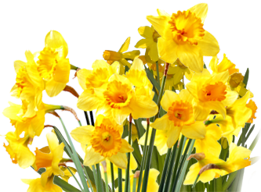
MOTHERING SUNDAY
14th March
10.30 a.m.-12 noon
You are invited to collect a posy of flowers to give to Mum or a family member.
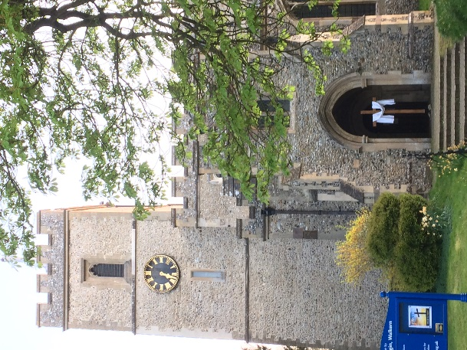
At ST MARY’S CHURCH
or
RECREATION GROUND
(by Budgen’s)

